FÉDÉRATION AÉRONAUTIQUE INTERNATIONALE  BALLOONING COMMISSION (CIA)  COMMISSION D’AEROSTATION  CIA Plenary  Hasle-Rüegsau, Switzerland  15-18 March 2023 | 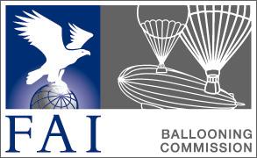

CIA New Technology Subcommittee AGENDA 2023

New Technology Subcommittee members 2022:
Claude Weber, Luxembourg (chairman)
Steve Ireland, Australia (member)
Erwin Pellegrom, The Netherlands (member)
Marc Andre, Switzerland (member)
Bengt Stener, Sweden (member)

2022 Minutes / Points of action

- Balloon Live project – Update, status and further development
  - Finances
  - Watchmefly developments
  - Recommendations for large events
  - Training
  - Other developments

- WRL report

- Reports on other new technology

- Work in and with other SC/WGs

- Other items

January, 2023
Claude Weber, New Technology Subcommittee Chairman

