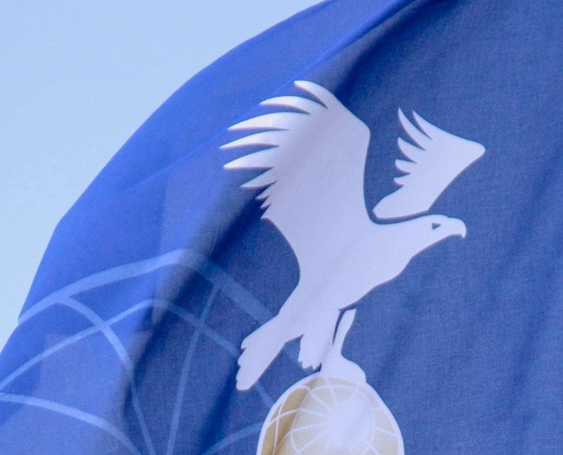

MINUTES

Rules Sub Committee
FAI CIA Commission

Online Event
16 March 2023

Ver.1 16.03.2023

Roll Call
Uwe Schneider AX-WG chairman
Hiromori Soejima S+SC-WG
Marc Andre, Erwin Pellegrom ScWG
Marc Andre AA-WG
Luc van Geyte BX-WG

Appologies
Marc Sullivan (handed AA chair to Marc Andre)

RSC-Working Groups’ summaries of recommendations
a) - AA/AM-WG summary of recommendations
b) - AX-WG summary of recommendations
c) - BX-WG summary of recommendations
d) - Scoring-WG summary of recommendations
e) - Statutes, By-Laws and Sporting Code-WG summary of recommendations

2022 Cat 1 Rules for approval
6th FAI Junior World Hot Air Balloon Championship 2023
66th Coupe Aeronautique Gordon Bennett 2023

Any other business
(none)

2022/2023 RSC and WG Members, RSC Chairperson
Members of RSC are by default the chairmen of the single working groups.
Present RSC chairperson Uwe Schneider is proposed for re-election by the plenary.

Summary of recommendations/motions to the CIA
See minutes of the 5 Working Groups.

Fédération Aéronautique Internationale
Avenue de Rhodanie 54
CH-1007 Lausanne
Switzerland
Tel: +41 21 345 10 70
Fax: +41 21 345 10 77
www.fai.org
info@fai.org

