Minutes

Scoring Working Group FAI CIA Commission
Blaser Swisslube & ZOOM, 15 March 2023

Ver. 1.0 – 15 March 2023

FAI – FEDERATION AERONAUTIQUE INTERNATIONALE – THE WORLD AIR SPORTS FEDERATION

ATTENDIES

Marc Andre (SUI) – Co-Chair

Erwin Pellegrom (NED) – Co-Chair

Bengt Stener (SWE) – Member

David Bareford (GBR) – Member

Mike Meinl (GER) - Member

Lynn Sullivan (USA) – Member (via ZOOM)

Christian Michel (GER) (via ZOOM)

Uwe Schneider (GER)

Gerald Stürzlinger (AUT)

Dominic Bareford (GBR)

- APPOLOGIES

None

- REVIEW

  - REVIEW 2022 SCORING WORKING GROUP MINUTES
No comments.

  - REVIEW 2022 CIA PLENARY MINUTES AND SWG ACTIONS
No actions referred.

COMPETITION OPERATIONS HANDBOOK (COH)

  - REVIEW UPDATES
    - NEW II.11
Just a minor update to refer to II.11 in penalty guide R10.2
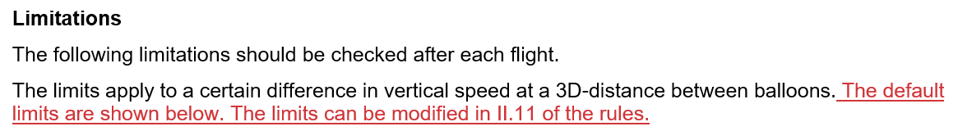

    - R6.13 TP to CP
It was agreed that penalties for GPS logger failure should be CP and not TP
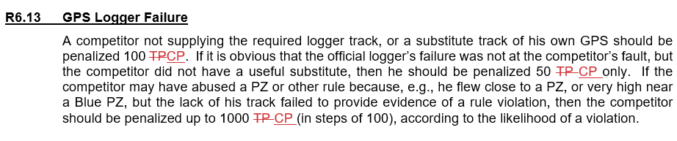

    - 1.6 ADD VEHICLES TO BUDGET
The cost of vehicles for officials, jury etc were added to the budget in 1.6
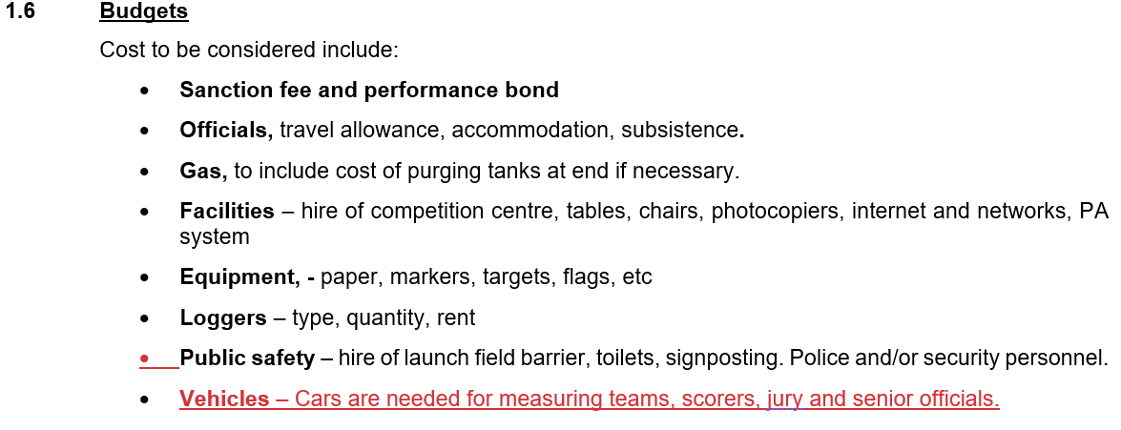

    - PENALTY FOR LOWER BALLOON IN CASE OF A COLLISION
It was agreed that when the lower balloon has a high vertical speed this would make it difficult for the higher balloon to avoid the collision, the penalty given should reflect this more. (Penalty guide R10.1)

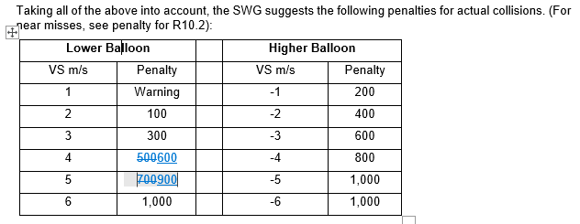
There also was discussion about exceptions to the suggested penalty points and an example for this was added (see 5.5)

    - R7.8 Coordinates
Clarify that 2 mistakes is not "inappropriate but unambiguous” anymore.

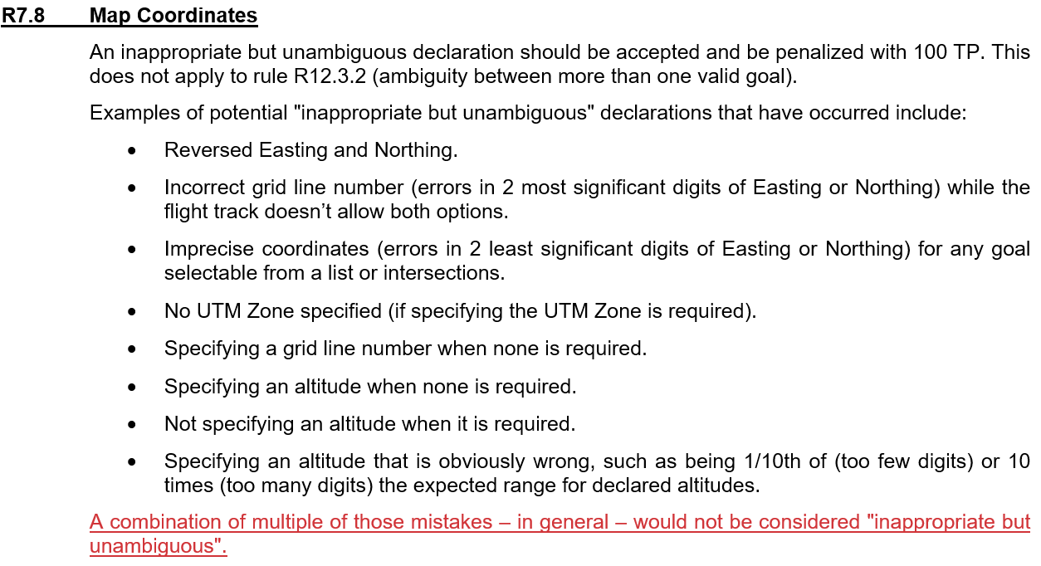

    - Fix links
Updated the links to documents on fai.org

- REFFERALS
ITEMS REFERRED TO THE SWG FROM EVENT DIRECTOR’S AND JURY PRESIDENT’S REPORTS, FROM OTHER SCS OR WGS BEFORE OR DURING THE CIA MEETING OR DISCUSSIONS OF ITEMS CURRENTLY PUBLISHED ON THE CIA-SWG FORUM

  - FROM AX: POINTS Formula CHANGE (P-NUMBER)
This was discussed and adopted at the AX-meeting and handles a change of the P-number in case of pilots not taking of for a flight. The P-number now varies per flight.
A minor update to the text was proposed back to AX and it will be included in the AX MER.

  - FROM AX: RED PZ CALCULATION
We are looking for a formula that would allow to define any shape for a red PZ and still have sensible penalties. At the moment it’s difficult to score for example the highway PZ.
Tabled questions are: do we include horizontal infringement? What would be the scaling factor.
The scoring WG will look for PZ-infringement examples of previous events to recalculate with the new formula and come with a proposal next year. (Erwin to lead)

  - REVIEW R6.9 PENALTY GUIDE
This part of the guide may need updating to promote a better learning curve for the pilots.
Recommendation to NTSC: rethink the numbering of declaration from 1-9 to letters and or colors. Examples to have numbers for marker drops and letters for declarations. Because of time limitations not all was discusses in full. Therefore the updates will be tabled for next year.

  - 10.9.1 DUTY OF CREW ON BOARD
Sentences have been clarified (also discusses during AX-meeting)
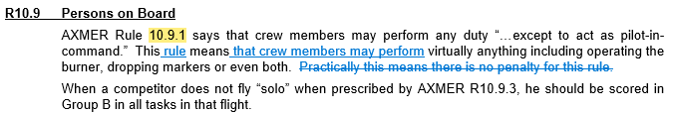

  - R10.2 (200ft ABOVE THE BALLOON)
There has been an addition to clarify what to do if a balloon initiates his descent close to the other balloon:
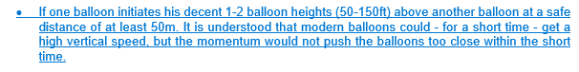

  - DOUBLING PENALTIES
After discussed during AX-meeting and in this group the following has been added to the COH
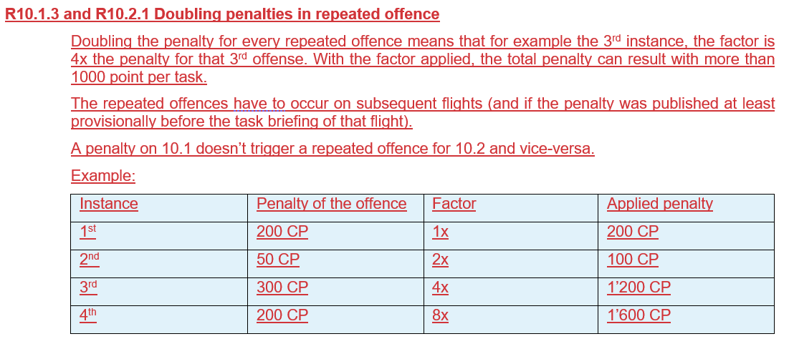

ANY NEW BUSINESS

None

- 2023 SWG CHAIRMAN AND MEMBERS

Marc Andre (SUI), co chair

Erwin Pellegrom (NED), co chair

Bengt Stener (SWE)

David Bareford (GBR)

Steve Ireland (AUS) ?

Lynn Sullivan (USA)

Mike Meinl (GER)

Marc Andre (SUI) will stop being a co-chair next year
David Bareford (GBR) will then take his place as co-chair

- MOTIONS

Approve the update to the COH and publish it as COH 2023

Note: Discussion on a new scoring formula is delayed to 2024 because of time constraints.

Fédération Aéronautique Internationale Avenue de Rhodanie 54
CH-1007 Lausanne Switzerland
Tel: +41 21 345 10 70
Fax: +41 21 345 10 77
www.fai.org info@fai.org

