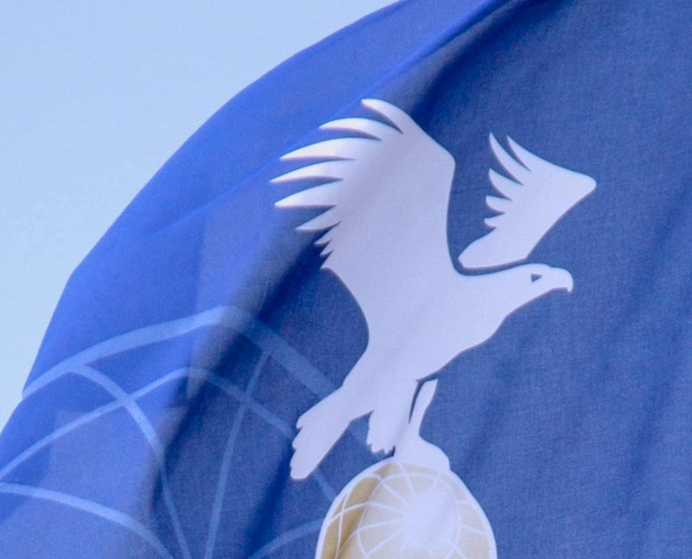

Minutes

Official’s Subcommittee
FAI CIA Commission
Blaser Swisslube headquarters: Hasle-Rüegsau, Switzerland

15 March 2023

Members:
Steve Ireland (Australia) Chairman
Hiromi Furukawa (Japan)
Sanne Haarhuis (Netherlands)
Hiromori Soejima (Japan)
Debbie Spaeth (USA)
Li Tong (China)
Lynn Sullivan (USA)

1/ Roll call, apologies for absence

Steve Ireland
Hiromi Furukawa
Sanne Haarhuis
Debbie Spaeth
Hiromori Soejima
Apologies from :-
Li Tong
Lynn Sullivan

Observers as follows:-
Sylvia Meinl
Katsura Endo

2/Review Official’s Subcommittee’s 2022 minutes.

The Subcommittee (SC) reviewed last years minutes and accepted them as representative of last years meeting.

3/ Points for action from last years plenary
PMR request for reviewing documents on the website.
This is an ongoing project involving all members as well as anyone involved with the CIA.

4/ Event directors list:

Update Event Directors (ED) list.

The SC has received one application for inclusion on the ED list. This was from Martin Wegner from Germany and is it was agreed that he fulfilled all the requirements of the selection criteria and he will be included on the updated ED list.
We have been contacted during the year by Dominik Haggeney who has requested to be removed from the list until further notice. He indicated that if he should change his mind in the future he will gladly go through the selection criteria procedure.

The current Event Director’s list is as follows: -

 | AX | AA | BX
David Bareford (GBR) | X
Thomas Fink (GER) |  | X
Martin Wegner (GER) | X
Markus Haggeney (GER |  | X
Eugenijus Komas (LTU) | X
Gary Lacey (AUS) | X
Garry Lockyer (CAN) | X |  | X  Pending application
Sylvia Meinl (GER) | X
Paolo Oggioni (ITA) | X
Paul Petrehn (USA) | X
Les Purfield (GBR) | X
Helmut Seitz (GER) |  |  | X  Pending contact
Hiromori Soejima (JPN) | X
Maury Sullivan (USA) | X
Claude Weber (LUX) | X

There was significant discussion with regard to the existence of multiple documents that pertain to the role of ED’s etcetera. It was decided that as a group the SC will extract any relevant documents from multiple locations for review and collation into a single document in a single location that can be used as a resource for future ED’s.

5/ Chief Officials list:

During the year emails proposed at the 2022 SC meeting were sent out to past chief observers and other relevant people to enquire if they wish to be included on a Chief Official (CO) list that can be accessed by future event organisers and directors for the purpose of contacting recommended officials in different countries. It was decided that the members of the list would be included into an email group similar to those used for contacting delegates etcetera. A welcome email will be sent to the the members of the list which will also inform them of the existence of the email group.

Due to some interesting feedback on questions regarding ED’s from the Competitor’s SubCommittee (CSC) annual survey there was some discussion that we contact the CSC to ask them to include expanded questions in next year’s survey

6/ Items referred from elsewhere
None
7/Any other business:

None

8/ Proposed Motions

None.
9/ Election of 2023 SC Members and Chairperson.

During the meeting one of the observers agreed to become a members of this SC. This was agreed by the current members and the following list is the current Official’s SC membership.

Steve Ireland (chair)
Hiromi Furukawa (member)
Hiromori Soejima (member)
Sanne Haarhuis (member)
Li Tong (member)
Debbie Spaeth (member)
Lynn Sullivan (member)
Sylvia Meinl (member)

Fédération Aéronautique Internationale
Avenue de Rhodanie 54
CH-1007 Lausanne
Switzerland
Tel: +41 21 345 10 70
Fax: +41 21 345 10 77
www.fai.org
info@fai.org

