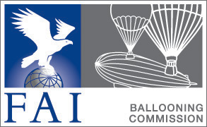

CIA Safety & Education

Subcommittee

Agenda Subcommittee Meeting 2023

Thursday 16th March 2023

Members : Benoit Pelard (FR) (chair)
Bengt Stener (SWE)
Rudy Paenen (BEL)
Andy Chau (HKG)
David Gleed (CAN)
Troy Bradley (USA)
David Strassman (GER)

- Opening of the meeting.

- Roll Call

- Apologies

- Reports from safety officers during 2023

- 65th Gordon Bennett race St Gallen / Stephan Zebelli
- 24th World Hot Air Balloon Championship /Christoph Fraisl

- Actions from Safety Officers Reports

- Safety officers for events in 2023

  - 66th Gordon Bennett 2023
  - 6th Junior World hot Air Balloon Championship 2023 Grudziadz, Poland
  - 5th Women World Championship 2023, Australia

  - 25th World Hot Air Balloon Championship Szeged, Hungary 2024

- Updates to the Safety handbook.

- Updates of Education material

- Miscellaneous.

- Nomination of sub-committee members.

- Nomination of Chairman.

