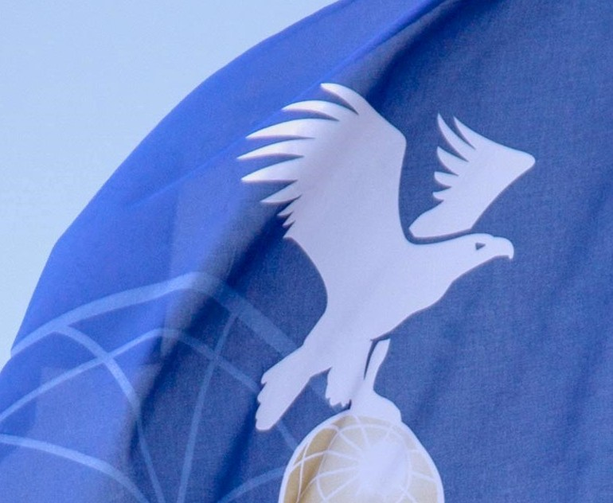

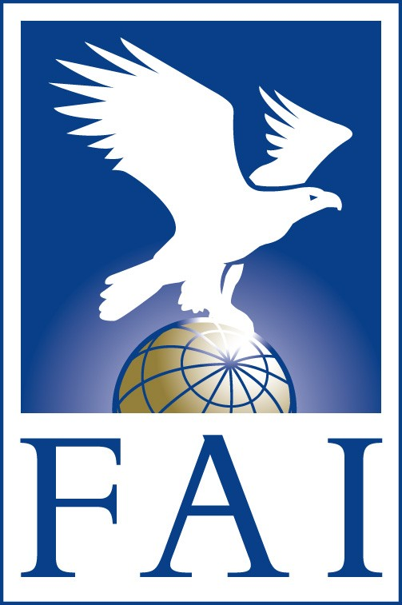
AGENDA

Scoring Working Group FAI CIA Commission

March 2023
Ver. 1.0 – 24 dec 2022

FAI – FEDERATION AERONAUTIQUE INTERNATIONALE – THE WORLD AIR SPORTS FEDERATION

ROLL CALL

- APPOLOGIES

- REVIEW

  - REVIEW 2022 SCORING WORKING GROUP MINUTES

  - REVIEW 2022 CIA PLENARY MINUTES AND SWG ACTIONS

COMPETITION OPERATIONS HANDBOOK (COH)

  - REVIEW UPDATES
    - NEW II.11
    - R6.13 TP to CP
    - 1.6 ADD VEHICLES TO BUDGET
    - PENALTY FOR LOWER BALLOON IN CASE OF A COLLISION

- REFFERALS
ITEMS REFERRED TO THE SWG FROM EVENT DIRECTOR’S AND JURY PRESIDENT’S REPORTS, FROM OTHER SCS OR WGS BEFORE OR DURING THE CIA MEETING OR DISCUSSIONS OF ITEMS CURRENTLY PUBLISHED ON THE CIA-SWG FORUM

  - POINTS FORMULA CHANGE (P-NUMBER)
  - RED PZ CALCULATION
  - REVIEW R6.9 PENALTY GUIDE

ANY NEW BUSINESS

- 2023 SWG CHAIRMAN AND MEMBERS

Note: The discussion on a new scoring formula must be delayed to 2024 because of time constraints

From : Marc Andre, Erwin Pellegrom

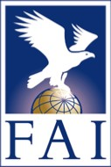

Fédération Aéronautique Internationale Avenue de Rhodanie 54
CH-1007 Lausanne Switzerland
Tel: +41 21 345 10 70
Fax: +41 21 345 10 77
www.fai.org info@fai.org

