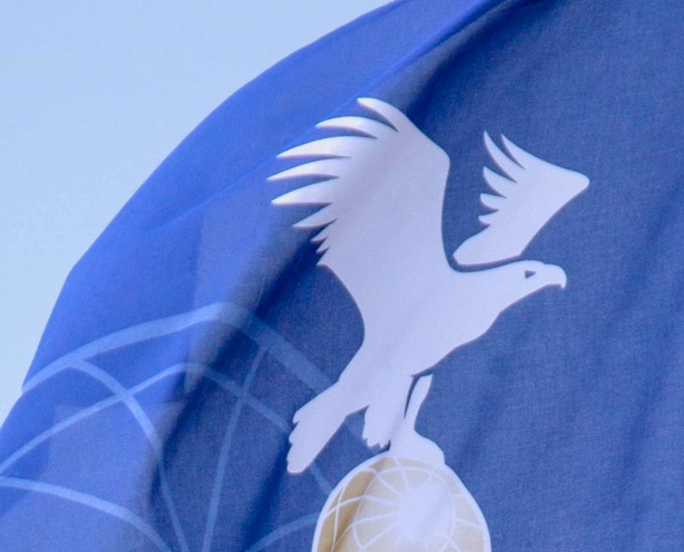

AGENDA

Rules Sub Committee
FAI CIA Commission

Online Event
16 March 2023

Ver.1 23.12.2022

TABLE OF CONTENTS

1 Roll Call Error! Bookmark not defined.
1.1 Subtitle 3

2 Appologies 3

TITLE

Subtitle

Roll Call
Uwe Schneider AX-WG chairman
Hiromori Soreima S&Sc
Marc Andre, Erwin Pellegrom ScWG
Mark Sullivan AA-WG
Luc van Geyte BX-WG

Appologies

RSC-Working Groups’ summaries of recommendations
a) - AA/AM-WG summary of recommendations
b) - AX-WG summary of recommendations
c) - BX-WG summary of recommendations
d) - Scoring-WG summary of recommendations
e) - Statutes, By-Laws and Sporting Code-WG summary of recommendations

2023 Cat 1 Rules for approval
6th FAI Junior World Hot Air Balloon Championship
5th FAI Women's World Hot Air Balloon Championship
66th Coupe Aéronautique Gordon Bennett

2023 CIA Sporting Events Sanctions

Any other business
(to be proposed at the beginning of the meeting)

2023/2024 RSC and WG Members, RSC Chairperson
Members of RSC are by default the chairmen of the single working groups.
RSC chairperson is proposed for election by the plenary.

Summary of recommendations/motions to the CIA
to be worked out during RSC meeting

Fédération Aéronautique Internationale
Avenue de Rhodanie 54
CH-1007 Lausanne
Switzerland
Tel: +41 21 345 10 70
Fax: +41 21 345 10 77
www.fai.org
info@fai.org

