
FÉDÉRATION AÉRONAUTUQUE INTERNATIONAL

AVIATION & SPACE EDUCATION COMMISSION (CIEA)

Developing Public Awareness And A Positive Attitude Towards Local Airports / Airfields

Note: This paper is intended to assist people wishing to work to save local airports and airfields and includes accounts of successful initiatives used to this end.

Index To Sections: Page

- Airfields Are A Special Place 1
- Evaluating The Role of the Airfield Within a Community 2
- An In-Depth Look At Airport Factors
- Negative Influences On the Airfield
- Projects and Activities Which Can Improve the Status of an Airfield
- Advanced Airport Enhancement Activities
- Attachments
- Airport Management Community Education
- Introduction To Air Sports
- Airport Kids Are Gone!
- Interactive Workshop For Community Leaders
- Airport Resource Forum
- Concept of an Airport Visioning Conference
- An Airport Economic Impact Study
- The Airport Perception Index

- AIRFIELDS ARE A SPECIAL PLACE

Airfields of airports can be as simple as a narrow strip of grass covered ground or can be a large area with long runways and acres of concrete ramps and many specialized buildings and businesses.

Regardless of size or purpose, all airfields should be considered as an asset to their town or city.

Why are airfields special?

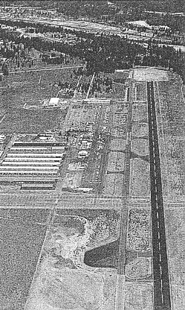
They accommodate airplanes landing and taking off as well as providing fuel and maintenance servicing.

They provide access to air transportation of passengers and cargo, be it commercial or a pilot flying his own airplane for personal business or pleasure.

They serve as a social and recreational center for aviation enthusiasts.

They offer a center for aviation education and training.

They often serve as a base for emergency and other public benefit flight activities.

They are usually a contributor to their communities’ local economy.
- EVALUATING THE ROLE OF THE AIRFIELD WITHIN A COMMUNITY
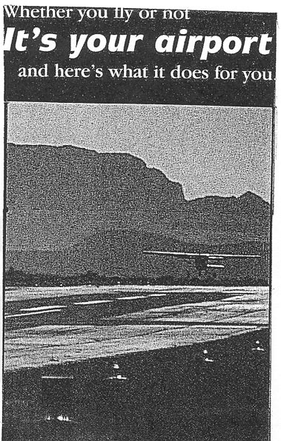
An initial simple evaluation of an Airfield can be achieved by considering a few basic questions:

Where is the airfield located and how did it get started?

Who owns the airfield and how is it operated?

What kind of airplanes use the airfield?

Are air sports a welcome part of the airfield activity?

Is the public welcome and encouraged to visit the airfield?

Are there acknowledged benefits to the community as a result of the airfield?

Is there a positive attitude about responsibility to users and the public?

- AN IN-DEPTH LOOK AT AIRPORT FACTORS

Most airports today are complex business facilities with many factors to consider in their operation.

The following is typical for a medium sized airport:

Role Of The Airport : Area Transportation Hub
Commercial Airline Service
Base For Private / Corporate Aircraft
Destination Stop For Transit Aircraft
Base For Emergency Air Services
Economic Generator For Surrounding Area

Aircraft Use Of Airport : Control Of Air Traffic
Adequate Runways / Taxiways / Ramps
General Safety Factors
Fueling Facilities
Airport Field Maintenance
Airport Security Measures
Limitation On Volume Of Traffic

Capital Improvements : Expand Airport Boundaries
Terminal Facility
Restaurant Facility
Runway / Taxiway / Ramp Improvements
Hanger / Aircraft Storage Upgrade
Lighting / Utilities Upgrade

Airport Activities : Site For Public Air Shows And Other Events
Recreational Area For Aviation Enthusiasts
Focal Place For Aviation Related Meetings
Public Visitor Center

Business Opportunities : On - Airport Aviation Services
Other ON / OFF Airport Businesses
Marketing To Recruit New Businesses
Tourist / Visitor Fly - In Destination

Land Use And Zoning : Expansion Of Airport Boundaries
Environmental Considerations
New Developments - Commercial & Residential
Relations With Existing Neighborhoods

Management Of Airport : Form Of Management Structure
Nature Of Planning Process
Policies And Practices
Communications With Users And Public
Criteria For Airport Success

Airport Financial Structure : Self Sufficiency versus Degree of Public Support
Proportional User Fee Structure
Dedicated Taxing Authority
Privatization

Other Topics ? : _________________________________________

_________________________________________

_________________________________________

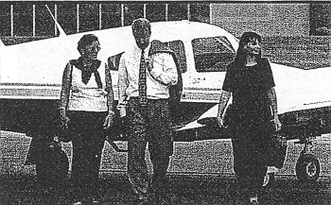

- NEGATIVE INFLUENCES ON AN AIRFIELD

Airfields are not always looked upon as a positive part of a town or other community. Too often those users of the airfield wait too long to organize a defence action against pressures to restrict operations or close the facility.

The most common factors appear to be :

- Unwarranted environmental concerns.

- Desire to use the airfield land for development of other commercial activity.

- Lack of good business practices and management.

- Lack of local public understanding and appreciation of the airfield activity. (Often people feel the airport has an unfriendly atmosphere for strangers.)

- Failure to communicate beyond those having a direct relationship with the airport.

- PROJECTS AND ACTIVITIES WHICH CAN IMPROVE THE STATUS OF AN AIRFIELD

There are at least three areas of outreach in which the airfield can develop relationships with the public. The non-flying public is subject to fallacies and misinformation about the airfield. Those pilots and others who understand the value of having an airfield in the community need to convince the citizens and elected officials of its importance.
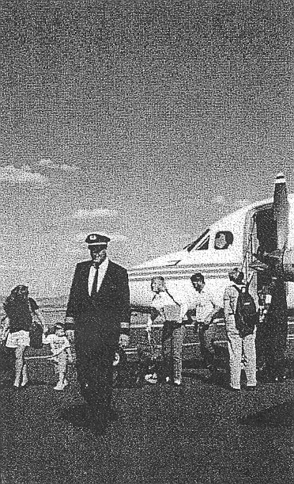
Outreach To The Community (see Attachment A)

- Compare the goals of the airport with those of the community and determine how they can be compatible and in the public interest.

- Be sensitive to community values and concerns and be responsive to complaints.

- Form a speakers group and target the organizations that can help develop community support.

- Insure that the airfield shows a visible interest in community affairs.

- Create a reason for elected officials and civic leaders to participate in activities at the airfield. (Examples: Commemorate a historic aviation event; present competition or recognition awards.)

- Contact the media and get acquainted with their policies and establish a relationship with the individuals that should be contacted for news items.

- Provide aviation oriented books and literature to the local library.

Outreach To The Individual Citizen

- Be a good neighbor and be responsive to complaints which often can be resolved with understanding of each others’ viewpoints.

- Most airfields hold open houses, air shows or other events. Special invitations appealing to a special segment of the community can be effective. (Example: grandparents bring their grandchildren; a war veterans day or a featured women in aviation day, etc. Themes work!)

- Establish an Airfield “Learning Center” in coordination with a local college / university and offer occasional lectures and discussion groups on aviation topics. (See Attachment B for example outlines.)

- Establish an Internet web site for airport information and notices of activities. (Most towns are coming on-line and would welcome additional features.)

Outreach To Schools And Youth Groups

- Invite teachers to review the CIEA aviation & space education “Guide” and “Instruction Aids” publications. (See Attachment C)

- Promote school class visits to the airfield.

- Encourage participation in the art contest for young people, the FAI Young Artists Contest and have a display of the local art work at the airfield.

- Organize a special day at the airfield for teachers and youth leaders. Introduce them to aircraft and arrange briefings on aviation topics.

- Sponsor a youth day with Young Eagle flights and consider ways in which organized youth groups can get involved with the airport.

Keep in mind that an enthusiastic young person tends to influence his parents, adult relatives and other adults such as teachers.

The effort to acquaint young people with aviation can present a challenge to them to become a pilot, choose a career in aviation related activities or just become an informed citizen with a voice on aviation matters. All are desirable for the future of aviation!

- ADVANCED AIRPORT ENHANCEMENT ACTIVITIES

Most airports are at least occasionally challenged to prove their value to the elected officials or to the local business community. Several successful approaches to this problem are described in this section:

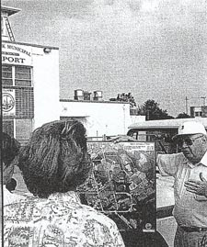
Interactive Workshop For Community Leaders
(See Attachment D)

Airport Resource Forum
(See Attachment E)

Concept Of An Airport Visioning Conference
(See Attachment F)

Airport Economic Impact Study
(See Attachment G)

Airport Perception Index
(See Attachment H)

It should be noted that each of these approaches have the common thrust of establishing communications between the airport and its community or town.

Another common pattern is the recommended use of a knowledgeable facilitator to conduct the activity.
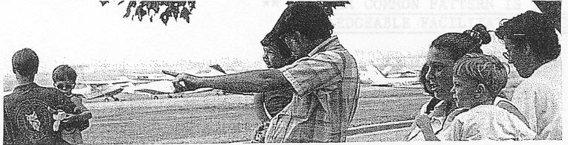

This document and its Attachments can be obtained from the CIEA web site at http://www.fai.org/education/resources

Or

From your national Air Sport Control Organization (Aero Club)

