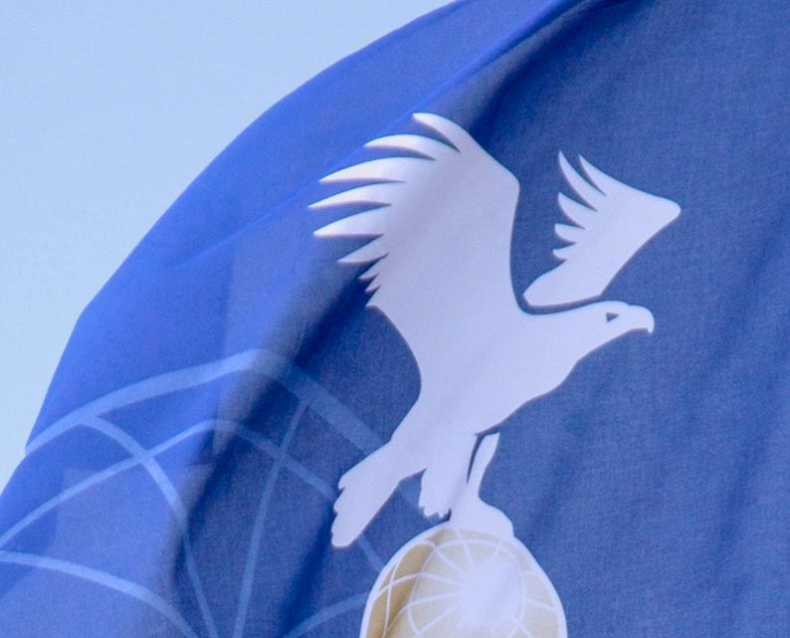

BALLOON YOUTHCAMP APPLICATION FORM
FAI CIA Ballooning Commission

Application for CIA Sponsorship Funds

Send completed application & support documents to CIA PMR Chair: CIA-media@fai.org

NOTE: CIA Sponsorship is voted on at the Annual CIA Plenary Meeting. Sponsorship amount subject to CIA Plenary approval.

Ver. 1 28/11/2019

CIA YOUTHCAMP APPLICATION FORM
Country ____________ CIA Delegate Name _________________________
Delegate email _____________________

Host Organization (Balloon Federation, Other?) __________________________
Camp Contact/Coordinator Name ______________________________
Email _______________________ Mobile ___________________

Location of Youth Camp
(Headquarter location - Park, School, Business Office, etc)
Property Name _________________________________
Address _______________________________________
City, State, Post Code ______________________________
Country ________________________

Dates Camp to be held __________________________________
Please include a brief history of this camp: Date first held, attendees who became pilots, etc.

Camp Attendees: Attach Youth Camp registration form.
Ages allowed _________________________________
Registration website ___________________________
Registration Cost for Attendees (in Euros) __________
Registration includes: (Food? Accommodations? Etc)
__________________________________________________________
Curriculum/Camp Agenda – Attach outline/details of the daily activities planned.

Notes:
- For Youth Camps that receive CIA Sponsorship funds, a written report must be submitted to the CIA after the camp but no later than December 1st of the same calendar year.
Send report to: CIA-media@fai.org
- Payment of CIA Sponsorship is made after receipt of the Youth Camp Report. Payment is Processed after approval by CIA Bureau.

Submitted by: _____________________________ Email________________
Date ________________

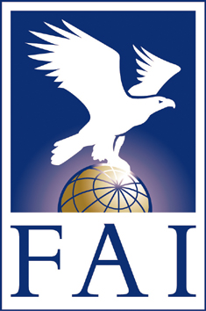
Fédération Aéronautique Internationale
Avenue de Rhodanie 54
CH-1007 Lausanne
Switzerland
Tel: +41 21 345 10 70
Fax: +41 21 345 10 77
www.fai.org
info@fai.org

