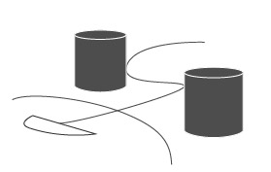
PG/HG Cross Country (XC)
Application Form for CIVL 2nd Category Event
We hereby apply toget FAI CIVL Category 2 sanctioning for the following event:
Discipline (mark X)
XC Hang Gliding Class 1 |  |  |  |  |  | XC Paragliding
XC Hang Gliding Class 2
XC Hang Gliding Class 5
XC Hang Gliding Class Sport
Event Name:
Country and Location:
Website:
(In English with registration page) )
Dates:
Reserve Dates:
Entry Fee:
Sanction fee:
(=2 pilot Entry Fee, min 70 CHF)
Application Deadline: |  |  | We aware that we shall submit application and proof of payment to the CIVL Competition Coordinator payment well before this 30-day deadline so it can be checked, eventually corrected and processed in time. Applications submitted just 30 days before the event have very little chance to be accepted. Ideal is when full application is received at least 37 days before.
We declare that the competition will be run according to:
- FAI: Sporting Code, General Section, Chapters 4 and 5.
- CIVL: Sporting Code, Section 7 Common, Chapter 12.
- CIVL: Sporting Code, Section 7 A.
Organizer Club:
Organizer Person:
Organizer E-mail and Phone:
National Airsport Control
The NAC has been notified and given approval for the sanctioning of the event.
NAC Name and Website:
NAC Official Name and Position:
NAC Official Email:
Signature and Name  of NAC official in Printed Letters: |  |  |  |  | NAC Organization Stamp: |  | Organizer’s Signature:

