AERONAUTICAL UNION OF SERBIA
and
AERO CLUB “Zivica Mitrovic”
Bela Crkva

FAI OPEN INTERNATIONAL
SPACEMODELING COMPETITION

2nd Bela Crkva Cup

WORLD CUP

Bulletin No. 1

SPORTING AIRFIELD “CRVENA CRKVA”
Bela Crkva - SERBIA
01.-02. July 2017.

AEROKLUB “ZIVICA MITROVIC” BELA CRKVA

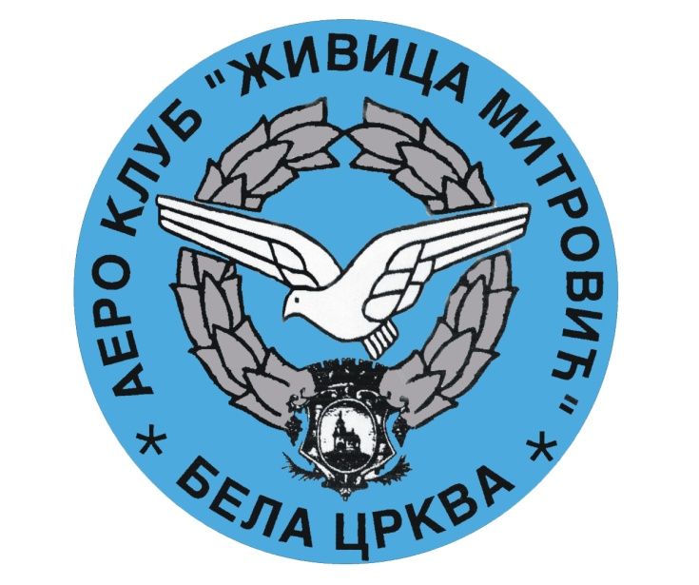

F A I OPEN INTERNATIONAL
SPACEMODELLING COMPETITION

“2nd Bela Crkva Cup” – WORLD CUP

Dear Spacemodellars
It is a great pleasure for NAC SERBIA
and AEROCLUB “ZIVICA MITROVIC” BELA CRKVA
to invite you to attend to the 2nd Bela Crkva Cup – World Cup
that will be held from 01. - 02. July 2017. in Bela Crkva.

We would like to welcome all of you in Belgrade

Sincerely Yours

President of AeroClub “Zivica Mitrovic” Bela Crkva
Mr. Zlatko Zak

Organizer: NAC SERBIA Aero Club “ZIVICA MITROVIC”
BELA CRKVA
Date: 01. – 02. July 2017.
Contest site: Sporting Airfield "Crvena Crkva"
44° 55' 27.133'' N 21° 22' 12.883'' E
Categories: WORLD CUP S4A, S6A,S7, S8E/P,S9A
Climate: Moderate continental climate
Participants: Competition is open for all members (juniors and seniors) of FAI
NAC having valid FAI sporting license
Rules: FAI sporting code section 4D issue January 1st 2017.
Official language: Serbian and English
Classification and awards:
Seniors and juniors will be judged together. Winners will be awarded with diplomas, medals and cups in each class
Food: Lunch will be organized on the field Free off charge
Entry fee: Entry fee is 30 euro per competitor
Banquet: 15 eura
Protest:
Protest must be made no later than 1 hour after the finish of each class, in writing accompanied by 30 euro protest fee
Frequencies: 35, 40 MHz , 2,4 GHz
Range safety officer: Dragan Jevtic SRB
FAI JURY: It will be published in the Bulletin NO 2
FAI S-7 JUDGE
Mr. Nikola Cvijeticanin SRB
Mr. Miodrag K Cipcic SRB
E-mail entry form : Dedline is 28.June 2017.
e-mail: akzivicamitrovic@gmail.com

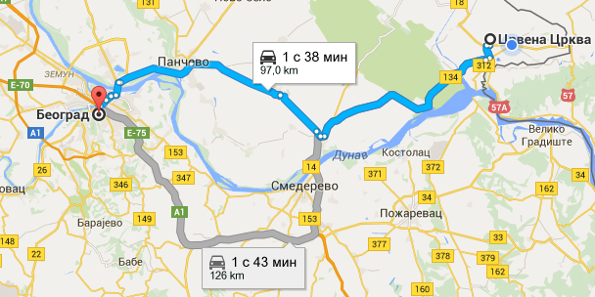

Accommodation:
1. Camping at the airfield: free of charge

2. Travel Agency Veltours
Adress: 1 Oktobar 95 26340 Bela Crkva
Phone Contact:
+381 13 852 - 772
+381 63 8254-070
Web- Site: www.belacrkva.org
E-mail: veltours@neobee.net

ORGANIZATION COMMITTEE:

Aero Club “Zivica Mitrovic” Bela Crkva SERBIA
Adress: 1 Oktobar 28 26340
Tel: + 381-63-8265-223

CONTACT PERSON:

DIRECTOR OF THE “2nd Bela Crkva Cup”: Mr. Zlatko Zak
Mobile: + 381-63-8265-223

Vice President Of Aero Club "Zivica Mitrovic": Sasa Petrovic
Mobile: + 381-61-168-8270

TIME AND SHEDULE:

Friday: 30. June 2017.
Arrival, delivery scale model and registration
16.00 - 20.00 on the Airport "Crvena Crkva"
Saturday: 01. July 2017.
07:30 - 08:00 delivery scale model
08:00 - 08:30 registration model of S4A
08:30 - 11:30 flights clas S4A
11:30 - 12:00 registaration model of S6A
12:00 - 15:00 flights class S6A
15:00 - 15:30 lunch
15:30 - 17:00 flight class S7 first round
17:00 - 18:30 flight class S7 second round
18:30 - Fly Off

21.30 - … Banquet and award ceremony

Sunday 02. July 2017.
08:30 – 09:00 registration models S9A
09:00 – 12:00 flight class S9A
12:00 – 12:30 registration model of S8EP
12:30 – 14:30 flight class S8E.P
14:30 – 15:00 lunch
15:00 – award ceremony and Departure

The organizers reserve the right to change the schedule as the situation demands

ENTRY FORM

The Aero Club of: ----------------------------------- intends to enter
A team consisting of :

No | Surname and name | Country | FAI Lic. | S4A | S6A | S7 | S8E/P |  | Frek/CH | S9A
1
2
3
4
5
6
7
8
9
10

DATE SIGNATURE AND STAMP

--------------- -------------------------------------------------------

