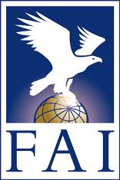
FAI Awards for Ballooning 2023
Nomination Form
(one nomination per form)

Name of the Award:
Montgolfier Diploma / best sporting performance in Gas Ballooning (By-Law 7.2.1.2.1)
Montgolfier Diploma / best sporting performance in Hot Air Ballooning (By-Law 7.2.1.2.2)
Montgolfier Diploma / best sporting performance in Roziere Ballooning (By-Law 7.2.1.2.3)
Montgolfier Diploma / contribution to development of ballooning (By-Law 7.2.1.2.4)
Santos-Dumont Gold Airship Medal (By-Law 7.2.2)
Submitted by:
NAC: _______________________________________

Name: ______________________________________

Position: __________________________ Function: _____________________

Date: __/__/____

Signature and stamp: _______________________________________________

Nomination for:
Name: ___________________________________________________________

Birthdate: __/__/_____

E-mail address: _________________________@_________________________

Reasons for nomination (maximum 250 words, English only):

Please provide at least one high resolution picture of the nominated person, if possible taken while practicing his/her sport or beside his/her (model) aircraft.
All nominations must be received at the FAI Head Office by 15 January 2023 at the latest in electronic format (to commissions@fai.org) preferably or by fax or post.

