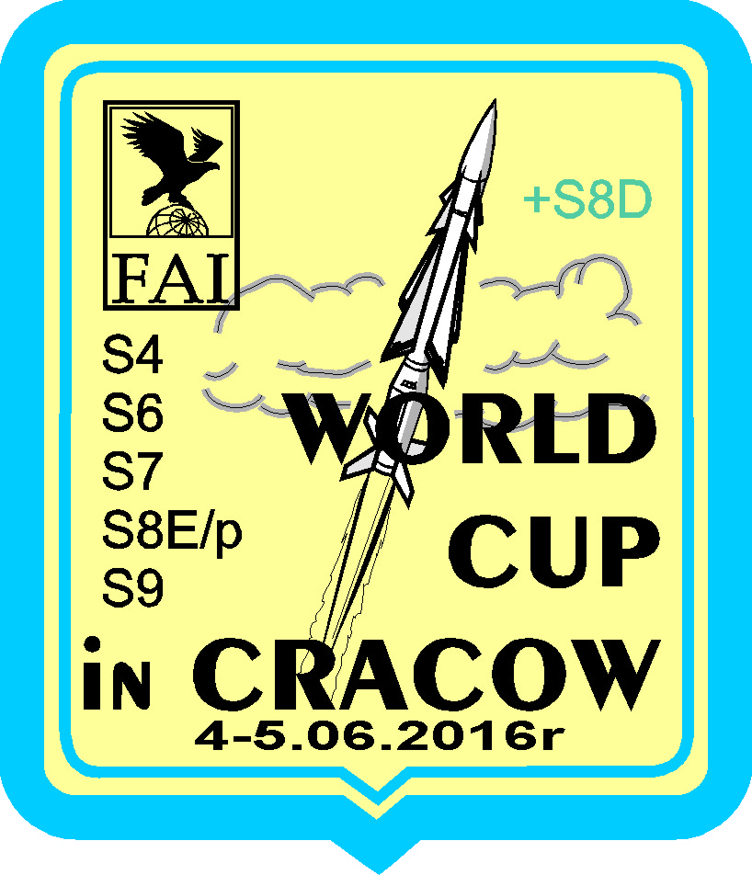
Organizer :
AEROKLUB OF CRACOW
MTSR SOWINIEC

FAI events : Saturday : S4A /World Cup/
S6A /World Cup/
S9A /World Cup/
Sunday S7 /World Cup/
S8E/p /World Cup/
S8D /Non WC ,Contest of Cup MTSR Sowiniec for juniors
only/

Contest Rules : The competition will be held according to the present FAI rules
Sporting Code FAI, Section 4b- General and Section 4d- Space Models

Participation : All competitors owning a valid international sport FAI licence
Without any restrictions, at their own expenses

Awards : Best individuals will be rewarded with sport trophies (diplomas, cups)

Launching site : The competition will take place on the Aeroklub Kraków airport in Pobiednik Wielki near Kraków / about 20
kilometers from the center of the city/
coordination’s : 50°04’59.65”N, 20°11’56.36”E

Entry forms : All the participants are kindly requested to confirm the participation
in the contest on the entry forms enclosed with this material
Entry forms must be send till 20 May 2016 to the address
/Earlier applications are preferred/

Tadeusz Kasprzycki
ul. Fiszera 2, 31-321 Kraków
POLAND E-mail : t.kasprzycki@wp.pl

Entry fee : Entry fee is 35 EUR for each participant/20 EUR juniors/. It cover the costs of :
- participation cards, informative materials, souvenirs
- sport trophies
- competitor gifts

Paymant : In cash at the arrival /for entry fee/

Protests : Protests are possible by one hour after event in writing together with a deposit of 20 EUR

Insurance : All competitors and visitors participate on their own responsibility /risk/
Organizer will not take the responsibility for any accident, damage or injury, caused by the models

Accomodation : Accomodation in the tent directly on the lunching site on the Aeroklub Kraków airport in Pobiednik Wielki / free/

Official languages : English, Polish

Frequncies : 35, 40 MHz, 2,4 GHz

FAI Jury : Mr Wladimir Svec /Slovakia/
Mr Paweł Janisiewicz /Poland/
Mr Jerzy Boniecki /Poland/

Safety Range Officer : Mrs Ewa Dudziak Przybytek /Poland/

Contest Director : Mr Tadeusz Kasprzycki /Poland/

Time and schedule:

Friday, June 3rd

4.00 pm - 8.00 pm arrival of the competitors at the airport in Pobiednik Wielki and registration

Saturday, June 4th

7.30 am registration competitors on the launching site (airport of Aeroklub Kraków)
8.00 am – 10.00 am delivery of the models for S7 class

9.00 am opening ceremony
9.10 am registration models S4A

9.30 am – 12.15 am flights S4A

12.30 am – 3.00 pm flights S6A

3.00 pm – 3.45 pm lunch time

3.45 pm – 6.30 pm flights S9A

6.30 pm – 7.00 pm time reserved for fly-off

7.30 pm prize giving ceremony

8.15 pm the evening meeting of all participants with a small treat and drinks
/free/ at the airport

Sunday, June 5th

8,30 am – 10.45 am flights S8D/for juniors only/

10.45 am – 12.45 am flights S7

12.45 am – 1.30 pm lunch time

1.30 pm – 5.00 pm flights S8E/p

5.15 pm prize giving ceremony and closing of the competition

In case of bad weather or any other case the organizer reserves a right to the change the timetable.

Entry Form

FAI OPEN INTERNATIONAL SPACE MODELS COMPETITION
World Cup in Kraków June3rd– June5th 2016 S4A, S6A, S7, S8E/p S9A

Full Name :_________________________________________________
National Aeroclub :___________________________________________

Address : ___________________________________________________
E-mail : ____________________________________________________

FAI Sporting Licence : ________________________________________

Declare the participation in the class :

S4A S6A S7 S8E/p S9A
Freq.: Chanel:
S8D/non WC-for juniors/

Prototyp Model S7 ; ___________________________________________

Tent on the lunching site

Size of T-Shirt : M L XL XXL

Date :………….. Signature ………………..

Please return to the organizer not later than May 20th 2016

