January 14, 2023

**To:** FAI / CIA

**From:** National Aeronautic Association, Balloon Federation of America

**Nomination for CIA Montgolfier Diploma for 2022 Sporting Year**

**A Major Contribution To The Development Of The Sport Of Ballooning In General.**

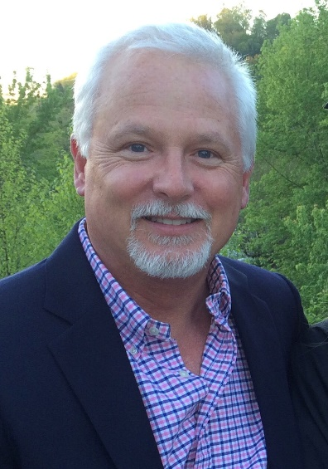

**Nomination for:**

Sam Parks

6116 Purple Aster Ln NE

Albuquerque, NM 87111

USA

**Sam Parks Contributions to Ballooning**

Director of Operations: 2018-2022 Albuquerque International Balloon Fiesta

Executive Director: 2023- Albuquerque International Balloon Fiesta

Balloon Flight instructor in both hot air and gas balloons

Founder and past President: Iredell Aeronauts Society (Statesville, North Carolina)

Past President: Carolinas Balloon Association

Past Board Member, National Balloon Rally Charities, Inc.

Past HACD Board President

Board member for 10 + years.

Along with Jim Thompson, wrote the HACD By-Laws when HACD was created

Part of Sub-Committee, along with Jim Thompson and David Levin to negotiate with

NABA to consolidate the two groups.

Part of the first “Competition Committee” created by BFA when the Competition

Division dis-banded. This kept competition ballooning going in USA.

Past President Balloon Federation of America

BFA Board Southeast Region Director

Alternate Delegate from USA to the CIA (Ballooning Commission of FAI)

Board Member: The Balloon Museum (Statesville, North Carolina)

Board Member: BFA Gas balloon Division

Founding Member/President: Aero Club of America, North Carolina Chapter

First balloon club in over 50 years dedicated to promoting and teaching

Gas Ballooning in USA.

Co-Chairman NFPA-58 sub-committee (2017)

Successful creation of new rules to allow the continuation of propane refueling

in hot air balloon fuel cylinders

Chairman NFPA-2 sub-committee (2021) Successful creation of new rules to allow the

Continuation of filling gas balloons with hydrogen.

Co-Chairman “Call to Action” Committee. Formed after Lockhart Texas Balloon accident

to communicate with FAA leadership (Washington DC) regarding regulations, safety

and airspace issues. We conduct monthly zoom meetings.

Committee Member: 2011 Balloon Federation of America Event Guidelines Manual

Chairman: BFA Safety & Education Committee

Committee Member: CIA Competitors Sub-Committee

Director: 1989 Low Hour Pilots Rally, Statesville, NC

Director: 1990 National Balloon Rally, Statesville, NC

Director: 1991-1996 Lowe’s Balloons over the Blueridge Balloon Rally, N. Wilkesboro, NC

Director: 1993-1998 Alamance Balloonfest, Burlington, NC

Director: 2006 BFA Southeast Regional Championship, Statesville, NC

Director: 2011-2017 Carolina Balloonfest, Statesville, NC

Director: 2010-2014 Freedom Weekend Aloft, Simpsonville, SC

Director: 2015- 2017 Freedom Balloonfest, Raleigh, NC

Director: 2019-2022 America’s Challenge Gas Balloon Race

Director: 2012-2014 Southeast Regional Championship, Simpsonville, SC

Director: 2007 Southeast Regional Championship, Baton Rouge, LA

Director: 2007 Louisiana State Championship, Baton Rouge LA

Director: 2021-2022 BFA JR. US National Championship, Longview Texas

Director: 2021-2022 Great Texas Balloon Race, Longview Texas

Deputy Director: 2016-2017 US National Hot Air Balloon Championship, Shreveport, LA

Director: 2023-2025 US National Hot Air Balloon Championship, Longview Texas

Assistant Balloonmeister: 2011-2012 Albuquerque International Balloon Fiesta

Balloonmeister: 2013-2018 Albuquerque International Fiesta

6 years in that position, no had ever exceeded 3 years in past.

While Balloonmeister, converted the AIBF scoring system to use the BFA scoring

program, providing a fairer way to score the event.

Deputy Director: 2011-2017 America’s Challenge Gas Balloon Race, Albuquerque, NM

Director: 2018-2022 America’s Challenge Gas Balloon Race, Albuquerque, NM

Safety Officer: 1998-2005 & 2008 National Balloon rally, Statesville, NC

Steward: 2010 19th World Hot Air Balloon Championship, Debrecen, Hungary

Steward, 2012 20th World Hot Air Balloon Championship, Battle Creek, MI

Balloon Federation of America: Award of Excellence 1995

Balloon Federation of America: Distinguished Aeronaut Award 2003 (highest Award in the Pilot Achievement Program)

Balloon Federation of America: Director’s Award 2007

Balloon Federation of America: President’s Award: 2017

AAAA: The Sid Cutter Award 2019

Balloon Federation of America: Shields Trauger Award 2022 (highest award of the BFA)

The nomination was for two different categories, “Exemplary Service to the BFA and Long-Standing Contributions to the Safety in Ballooning”

Organized Manufacturer’s Summit in 2015 during Balloon Fiesta. First one in 20 years

As a result of summit, created the FIIT program within the BFA

Ballooning safety seminar organizer and speaker

Balloon event organizer/consultant

Currently working with FAA as a subject matter expert regarding 14 CFR 91.225 (Requirement of ADS-B equipment within class C airspace). My goal is for Lighter Than Aircraft to be exempt from 14 CFR 91.225 while flying inside Class C airspace.

***For these notable life time accomplishments and important contributions to the sport of ballooning, we proudly nominate Sam Parks for the Montgolfier Diploma*, *Major Contributions To The Development Of The Sport Of Ballooning In General.***

Sincerely Sincerely

Orvin E Olivier Patrick Cannon

Awards Chairperson President

Balloon Federation of America Balloon Federation of America