World and Continental Gliding Championships

Bid Form

This bid application process is now in 2 parts;

Part 1 is completion of the new FAI application for Organisers Agreement which is a fillable .pdf found here
https://tinyurl.com/igcbid2023
**ONLY COMPLETE PAGE 1 – PAGE 2 IS FOR ME TO COMPLETE**

Part 2 is completion of the more traditional IGC bid which is contained in this document

Both documents need to be received before midnight UTC on 31st December.

If your bid is approved this OA request form is sent to FAI and informs them to produce the Organisers Agreement document for your event. It is therefore very important that the FAI Organisers Agreement application document is completed as accurately as possible.

All of the information sought in Part 2 of the bid document should be completed as fully as possible prior to its submission. Details, such as a diagram of the airfield, may be included as an Annex. When completed an electronic copy of these forms should be sent to the IGC Bid Manager Mandy Temple
mandytemple.australia.igc@gmail.com before the deadline of midnight UTC 31st December of the year prior to the presentation of the Bid to the IGC Plenary.

If your bid is approved the Contest Director and Sporting Director must sign the last page of Part 2 of the bid document - which is binding. Both of these documents will then be sent to FAI and will form the Organisers Agreement.

SECTION A MANDATORY

Organisation Structure and Personnel

In order to improve the quality of contests, from 2024 we are planning to adopt a new Structure with an overall Contest Director and an IGC approved Sporting Director - subject to Plenary approval.

This new proposed organisation structure is shown below.
This is a work in progress and there may be some adjustments in the future.

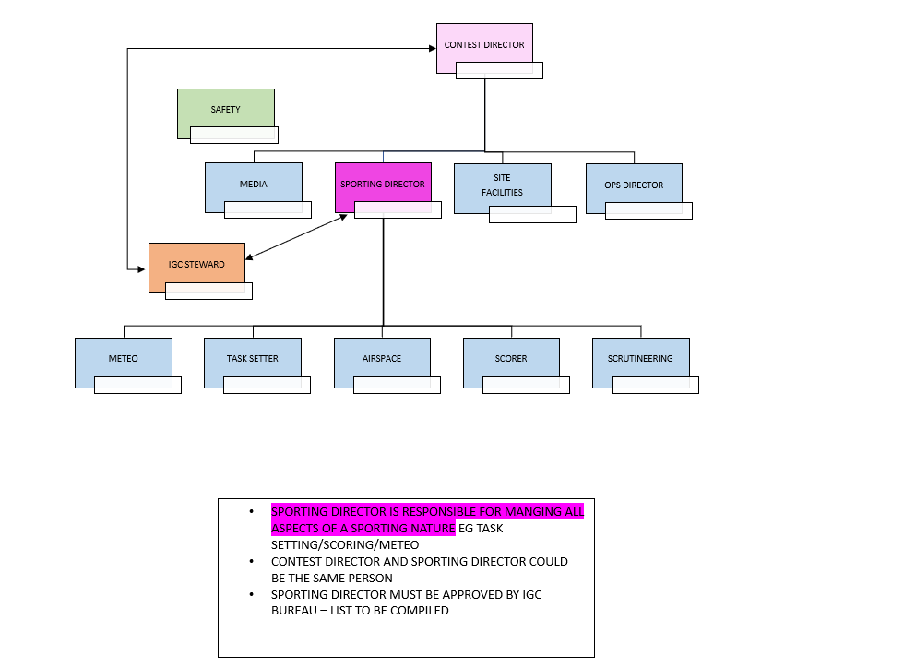

Please list as many of these officials as possible. Those marked * Must be named
Contest director *
Scorer*
Sporting director* May be marked TBA but must be agreed to at least 2 years before start of contest
Media
Site facilities Director
OpS Director/Safety
Meteo
Task setter
Airspace
Scrutineering

Site

Name address of the airfield

Co-ordinates of the airfield

Direction and distance to nearest international airport,

Experience of the event team in organising championships

Proposed period for the event (in accordance with Annex A 1.2.3)

Training Dates

Competition Dates

Alternate dates for training (preferably greater than 3 weeks from primary bid dates in 2.2.1)

Alternate dates for competition (preferably greater than 3 weeks from primary bid dates in 2.2.2)

Airfield operating data (provide details for the following)

Surface of airfield, number and directions of runways (provide diagram and photograph)

Ratio of Tow planes to entries (As a guide; organisers should have sufficient tugs to be able to offer all gliders a launch in about 60 minutes.)

Meteorological facilities that will be provided

Parking facilities for gliders.

Repair facilities for gliders

Repair facilities for radios and instruments

Oxygen requirements and supply facilities, if required

What plans do you have to implement the FAI Environmental Code of Conduct during your event?

Airfield Infrastructure
(provide descriptions and or photos of the following facilities at the airfield)

Briefing Room & suitable equipment

Common Room(s) for the competitor

Suitable meeting Room for the International Jury and Stewards

Bar and or restaurant

Press Centre

Communication and internet equipment

Post and Banking

Insurance availability

Toilets, wash rooms and shower rooms

Car parking

Emergency (including fire)

Medical and First Aid

Conference and office rooms for the OSTIV Congress, if required

Competition office hours

Social event planned during the event

Availability of water for ballasting

Accommodation and food for competitors
(provide details of the following with an indication of cost)

Accommodation in the local area

Accommodation at the airfield

Camping facilities at the airfield
include details of bathroom facilities and ratio of each to the number of people camping e.g. one toilet per 10 campers. How many toilets at the grid?

Catering for competitors at the airfield

Task area (provide details of the following)

Topography in the task area

A comprehensive survey of meteorological conditions

Restrictions in the task area

Airspace in the task area

Typical tasks to be expected

Road and traffic conditions

Rules (Note: The Championships must be conducted in accordance with the FAI Sporting Code)

Indicate the options intended to be used from Annex A for:

Starting procedures

Tasks

Finish procedures

Scoring

Indicate any particular conditions or possible restrictions that may be applied:

For pilots and crews

For sailplane and equipment

Number of competitors: State the maximum number of competitors that may be entered the competition

Provide explanation for this number

Indicate how the classes will be separated for:

Starts

On task

Finishing and landing

(In CGC only) In 20m Class please indicate if you intend to allow one or two gliders per NAC

Entry Fee

Provide details of the costs in Euros or USD of the Local Entry Fee and the Aero Tow.
The bid should take into account inflation. We do not want to amend these fees once approved.
We request that you specify parameters that were used to calculate the Entry fee and Tow costs and how changes in those parameters would change the Entry fee and or Tow Costs eg Entry fee will be $1000 if inflation is 2% or $1500 if inflation is 5%.
Eg Aero Tows will be 50USD if the fuel cost is 2USD per litre. If the fuel cost is 3USD per litre the Tow cost will be etc etc.
Also include the case where costs could be reduced.
.
If this bid is accepted no further increases to Local Entry or Tow costs will be approved

Entry Fee Part a) IGC Sanction fee (This is indexed and published. It is quoted in CHF.)

Entry Fee Part b) Local entry fee component (see note above It is your responsibility to make a forward inflation calculation as this is a binding commitment)

What is included in the entry fee? (Annex A 3.4.2)

Additional fees, memberships etc not included in the entry fee

Cost of aero tows (as per note above)

SECTION B NON-MANDATORY

Rental cars

Accommodation (as appropriate for local facilities)

Hotels

Apartments

Bed and Breakfast

Camping (as per note above)

Catering

Hotels

Restaurants

Glider Hiring (provide information on the following)

The availability of local gliders for hire

The costs of hire (as per note above)

Any restrictions on hire (e.g., license requirements)

Glider Import (provide information on the following)

Ports or cities of entry

Customs requirements

Customs brokers

Estimated costs and fees, including cost of transport of containers

Training

Provide details of any proposed training opportunities for teams and individuals prior to the Championships. (please note that if you organise training competitions, these cannot be called pre-World Championships or pre-European Championships)

Trackers

Give details of which tracking system is to be used during the contest. Note that it is expected that IGC trackers will be hired as 1st preference.

Miscellaneous

Visa Provide relevant information

Licence Advise any special licence requirements? E.g., Instructions in case of a validation is needed

Agreement (to be completed if bid is accepted)

I ........................................................... being the Contest Director for

and
I ........................................................... being the Sporting Director for

...............................................................................................................

Agree that;

- I will fulfil all undertakings listed in this bid document
- The event will be run in accordance with the FAI Sporting Code
- Work with the Chief Steward prior to the event to ensure that the published IGC Timeline is followed and milestones are met
- I will seek advice from the Chief Steward if I am unsure of how to proceed at any time

Signature................................

Date....................................

Witness................................

Signature................................

Date....................................

Witness................................

